Truss Problem Data
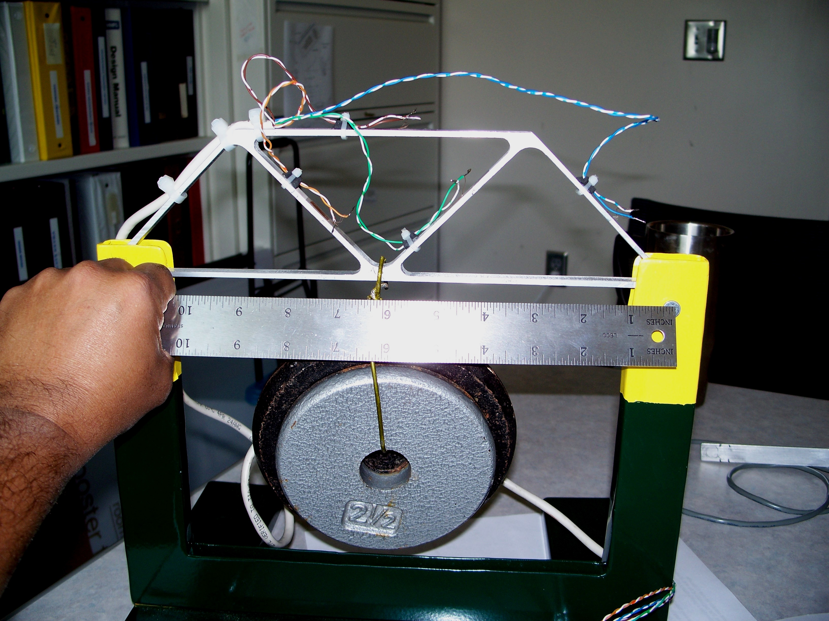

Figure 1. Loading the truss problem (Not to scale and not the actual aspect ratio)

The three (two on bottom, one on top) horizontal segments are 6" long, while the segments at angle are all 4" long.
The strain gage reading on the green wire segment was found to be 13.5 μin/in.
The load placed at the center location was 17.5 lbs
Cross-sectional area of all members was slightly different but take it as 0.398" x 0.139"

