Chapter 02.00B

Physical Problem for Differentiation

Chemical Engineering

At about 11:56 am on June 22, 1969 near the city of Cleveland in Ohio, an oil slick on the Cuyahoga River caught fire that burned for 24 minutes. This incident on a navigable river acted as a catalyst for congress to pass the Clean Water Act in 1972. The Federal Water Pollution Control Act prohibits the discharge of oil or oily waste substances or hazardous substances into or upon the navigable waters of the United States.
Interestingly, recreational boating is a growing activity in many waterways of the United States. Unfortunately, fuel leakages – however small – from so many boats can lead to formation of large oil slicks. The ideal would be for the recreational boats to use fuels that can evaporate as quickly as the fuels leak onto the surface of water.

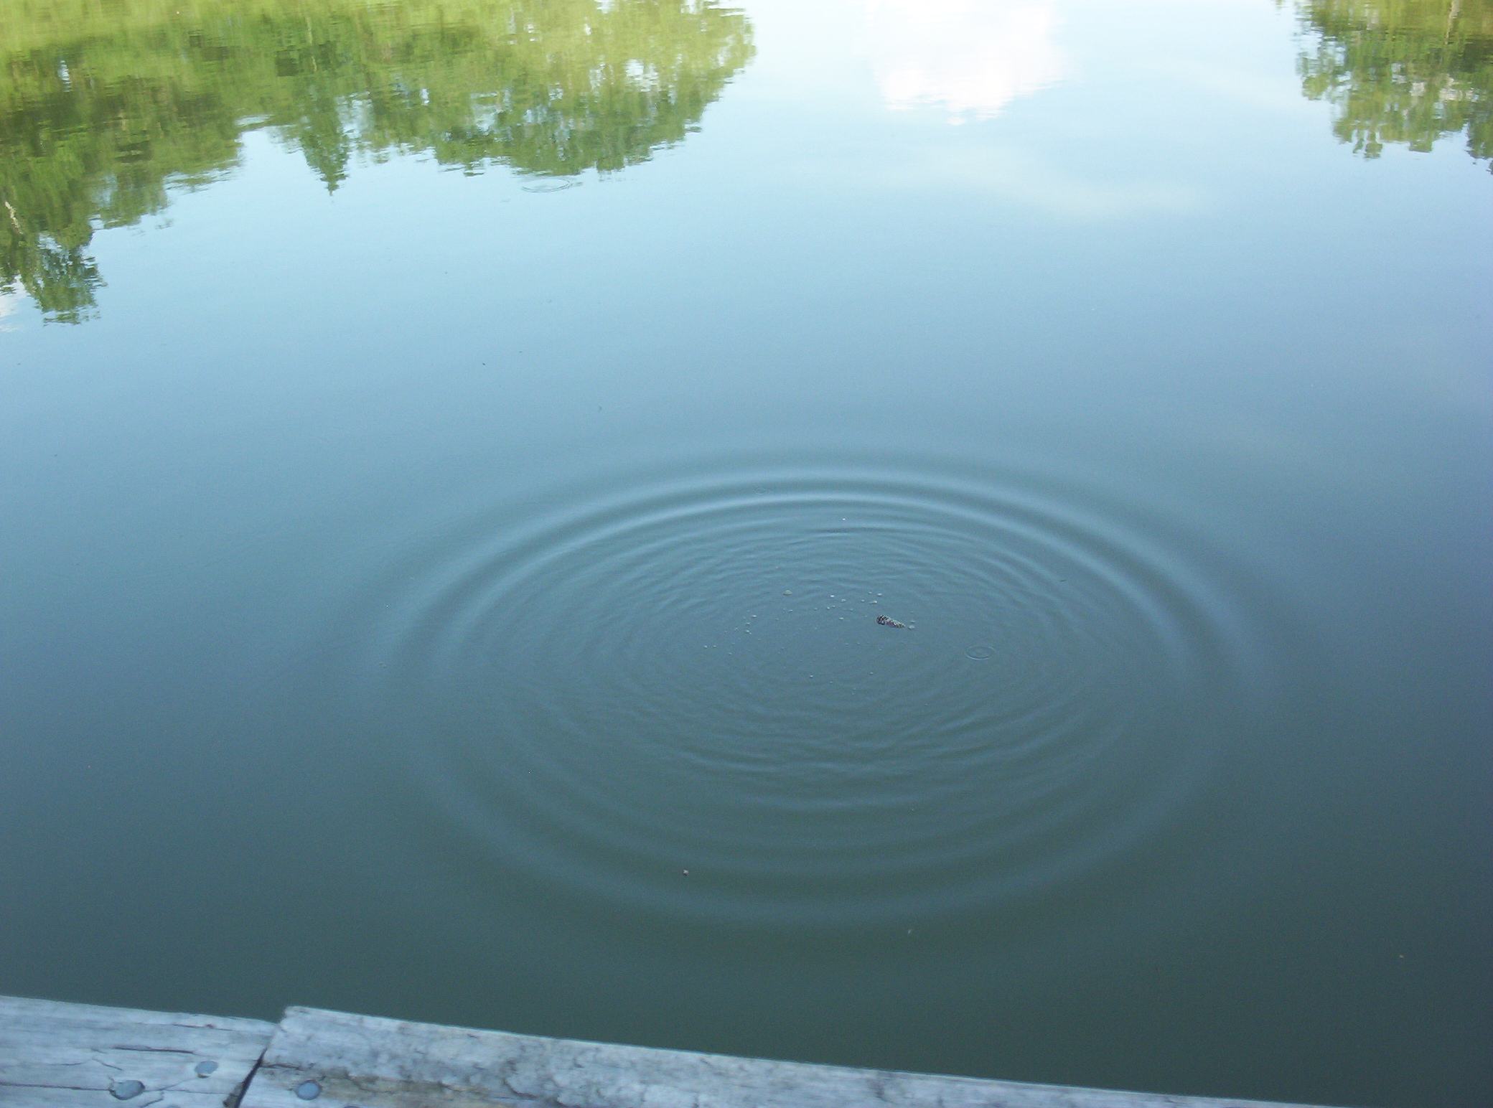
Figure 1 Waves generated on a pond by a pebble
A new fuel for recreational boats being developed at the local university was tested at an area pond by a team of engineers. The interest is to document the environmental impact of the fuel – how quickly does the slick spreads? Table 1 shows the video camera record of the radius of the wave generated by a drop of the fuel that fell into the pond. To find the rate at which the contamination spreads requires numerical differentiation.

Table 1 Radius of wave generated as a function of time.
Time () | 0 | 0.5 | 1.0 | 1.5 | 2.0 | 2.5 | 3.0 | 3.5 | 4.0 | 4.5 | 5.0
Radius() | 0 | 0.236 | 0.667 | 1.225 | 1.886 | 2.635 | 3.464 | 4.365 | 5.333 | 6.364 | 7.454

QUESTIONS
- Compute the rate at which the radius of the drop was changing at 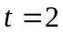 and 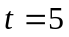.
- Estimate the rate at which the area of the contaminant was spreading across the pond at and .

Topic | DIFFERENTIATION
Sub Topic | Physical Problem
Summary | Estimating the rate at which area of containment is spreading
Authors | Egwu Kalu
Last Revised | June 21, 2005
Web Site | http://numericalmethods.eng.usf.edu

